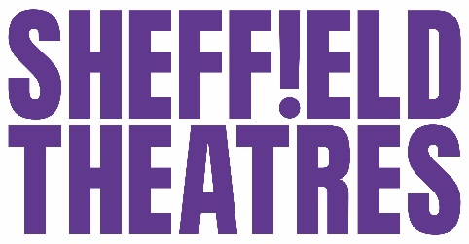
Your visit to Sheffield Theatres

We stock a variety of ice creams and soft drinks for your party to enjoy during the interval, including Our Cow Molly ice cream tubs made right here in Sheffield!

Save time on the day by pre-ordering in advance of your visit, just fill in the below form and return to us in one of the following ways:

Post: Offstage Ltd, 55 Norfolk Street, Sheffield, S1 1DA

Call: 0114 249 5999 and ask for the Catering Department

Email: pre-orders@sheffieldtheatres.co.uk

Name of Party:
Telephone Contact: Telephone Number:
Crucible Main Theatre/ Crucible Studio/ Lyceum Theatre (Please delete)
Name of Show:
Date of Performance: Time:
Product | Flavour | Unit price | Quantity | Total
Our Cow Molly Tubs (made in Sheffield)
 | Just Molly | £2.60
 | Strawberry | £2.60
 | Chocolate | £2.60
 | Mint Choc Chip | £2.60
 | Lemon & Ginger | £2.60
Cadburys Dairy Milk Stick Bar |  | £2.50
Cadburys Flake Cone |  | £2.50
Product | Flavour | Unit price | Quantity | Total
Robinsons Fruit Squeeze Lolly |  | £1.50
Pepsi 500ml | 1 | £2.00
Diet Pepsi 500ml |  | £2.00
7 UP 500ml |  | £2.00
Tango Orange 500ml |  | £2.00
Fruit Shoot |  | £1.40
Mineral Water |  | £1.65
Total (Inc. VAT)

Please place your order one week in advance to ensure availability
If your choice is not available, we will replace with the nearest alternative at no extra cost.
Please get in touch if you wish to have alternative options for a party of young children.

Payment can be made via cash, card or a cheque made payable to ‘Offstage Ltd’ on the day.
Advance payment can be made with a cheque made payable to ‘Offstage Ltd’ prior to the event date.

Collection of your order on the day
Crucible Theatre: Side of Red Door at Interval
Lyceum Theatre: Stalls ‘Sweets’ Kiosk at Interval

